What is the different between the two Toy - breeds?
BREED -PERSONALITY : THE AUSTRALIAN SILKY TERRIERS
The Australian Silky Terrier is a courageous, robust, elegant, and graceful toy breed dog. According to his name he has shiny blue and tan coat, or gray blue and tan coat, which dos not shed.
The Silky Terrier is protective of its own territory, making it a good little watchdog, announcing the presence of strangers.
He will not leave your side, always watching for your love and affection, whether for adults or kids this little dog is a MUST!
The Silky is approximately, 23 cm to 25 cm (9-10 in) shoulder heights. This proud little dog loves early handling and training.
The Silky's texture of coat prefers daily- grooming; 3-5 minutes will be beneficial. Its hair parts down the middle giving the appearance of a well-groomed dog.
Life expectancy is approx.14 years. 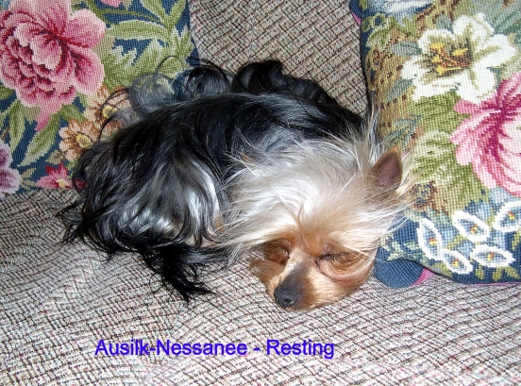
PLEASE TAKE NOTE: The Silky or Yorkshire Terrier is not suited to being an outdoor dog only.
Ideal owner/s: Those who require a family companion and are prepared to have the dog living indoors or in A enclosed backyard most of the time. When you select your puppy, you will have spent quite some time considering exactly what breed of puppy you should buy. What size would best fit in with your household, how much exercise space and time the dog will receive, how much he will cost to feed house and keep in good health and condition etc. Having decided all this, knowing what type of temperament your dog will need to have to fit in happily with in your family or around your children is essential.
Dog or Bitch? The choice between dog and bitch is also of preference. "Yes" you made the best suitable decision the Australian Silky Terrier or the Yorkshire Terrier is the right family toy dog made for Australian conditions.
The Silky Terrier is a bit more suitable to the Australian climate and is much easier to handle generally. They are hardy, non-shedding odourless popular house pets.
The Australian Silky Terrier and the Yorkshire Terrier is friendly to all the family but will usually attach itself to one member. It will love children if raised with them, but it doesn't enjoy being fussed over or being treated like an animated toy and prefers to be treated as an equal. Like most long coated dogs, the Silky and Yorkie loves being groomed, provided this procedure is started at a very early age. The amount of grooming required is dependent on the actual length of coat your Silky or Yorkshire Terrier has inherited. If you can’t commit to the grooming (brushing), frequently trimming to keep the coat short in an alternative. See picture: * Trimmed
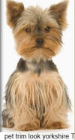Terrier.
REED PERSONALITY / CHARACTERISTICS / TEMPERAMENT
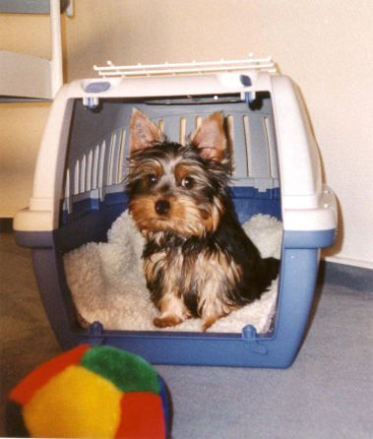
This transport box is the best to (toilet) train your puppy at night time. But please look the door! Bed time 9 pm - UP in the morning 6 am at the time your puppy wakes up take it outside to a grassy space to do his/her business. ALL small dogs should be allowed to sleep inside, so set the bed in a place that will be suitable to you and your Silky or Yorkshire Terrier.
IN CONCLUSION

Now you know a little about the Australian Silky Terrier and Yorkshire Terriers, and have decided this is the dog for you or you want more information, make contact whit the breeder or club or your State controlling body for pure breed dogs as listed on the website: www.ausilk.com
Puppies, sometimes, available from quality healthy stock. Also carefully selected, breeding stock while breeding to our Silky standard to produce best possible quality. Raised in a family home environment with lots of love and attention. And with the age of 8 to 10 weeks old they are able to leave home. They are all Vet checked, wormed, and vaccinated and micro shipped, DNA tested.
And registered pedigree from  dogs registered in Queensland.

Be aware of: Back-yard breeders!
So many people have bought an appealing "little" puppy which was sold to them as A Australian Silky Terrier, OR Yorkshire Terrier?
( or a "DESIGNER DOG"), Labradoodle or a Cavoodudle and so on. Only to find out later, that the father was a Blue- Heeler etc.
I am firmly against crossbreeds. The downside is you can’t blame the dog for the outcome, later in life. When you buy a pure breed, you know exactly what you are going to get. 98 %
(We can never hope to purge the breed of all defects!
But through selective breeding we can work to stack the "genetic deck" more in our favor over the years.) Even an expert cannot look at a 6-8 week old cross breed and guess his ultimate weight, size, coat or very important character or what about any medical issues? This is not to say that you should not buy a cross breed dog from an animal shelter this is your choice after all. Rather that you should keep all these points in your mind when considering to buy a small Australian Silky OR Yorkshire Terrier, the buyer should look for a breeder who is a registered member of a Dog club and produces pedigree puppies that fit the breed’s physical description. So please purchase one from a well-
Known and registered licensed breeder who is a member of the

Please ring as if you have more Questions about Silky or Yorkshire Terriers. The Breeder.

